A PROJECT REPORT

ON

"STATIC WEB-HOSTING IN S3"

*Submitted in partial fulfillment of*

*Master In AWS Cloud Technology*

**

**Session: 2024**

***ITVEDANT EDUCATION PVT. LTD,***

***HYDRBABAD***

**Submitted To: Submitted By:**

**Mr. Amith Sharama bolla sandeep**

**TITLE:**

*Hosting a Static Website in S3 "Simple Storge service"*.

**DESCRIPTION:**

* S3 is primarily designed to store and retrieve data. However, it can also be used to host static websites by making use of its web hosting capabilities. When you host a static website in S3, you're essentially storing your website files in S3 buckets and configuring them to serve as a static website endpoint**.**
* A static website consists of HTML, CSS, and JavaScript files and does not require any server-side code.
* If you have custom domain, configure DNS settings to point to bucket endpoints.

**BENFITS:**

Hosting a static website on S3 include low cost, low maintenance, automatic scaling, and security. The cost of hosting a static website on S3 is based on the number of GET requests and the amount of data transferred out of the bucket. The maintenance of the website is reduced because there is no server-side code to maintain and no web servers to configure and keep up to date. S3 automatically scales to handle increases in traffic, and there is no server to be vulnerable to attacks. However, it is still important to secure your S3 bucket by following best practices for bucket security.

**Project Steps:**

**STEP 1:**

**Plan Your Website Structure:** Determine the structure and content of your static website, including the HTML pages, CSS stylesheets, JavaScript scripts, and image assets**.**

**STEP 2:**

**Create an S3 Bucket**: Log in to the AWS Management Console, navigate to the S3 service, and create a new bucket with a unique name. Choose a region that aligns with your target users.

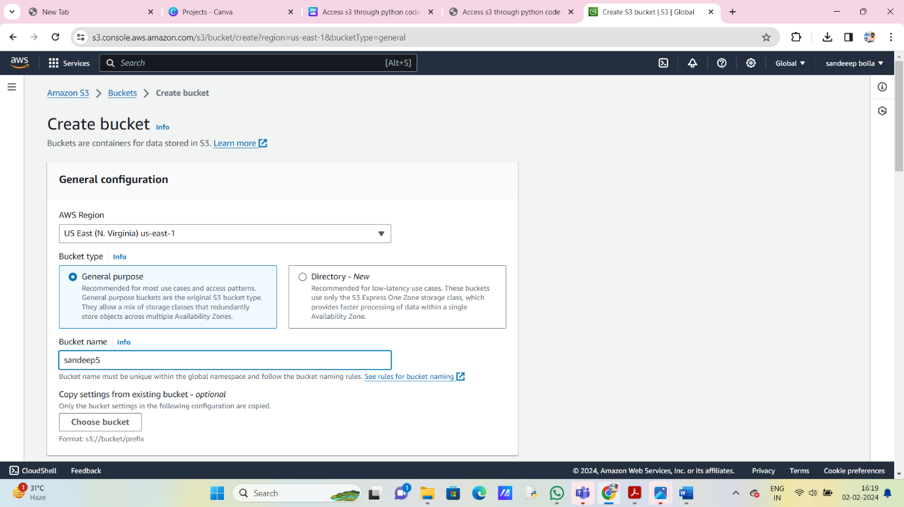

**STEP 3:**

**Backup and Security:** Implement backup strategies to protect your website data. Consider enabling versioning and logging in S3, and regularly review security settings to prevent unauthorized access.

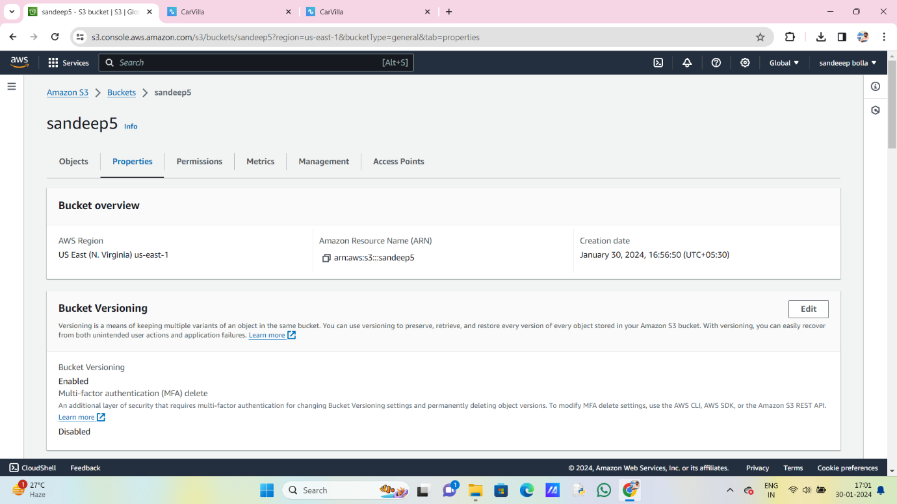

**STEP 4:**

**Upload Website Files:** Upload your website files to the S3 bucket using the AWS Management Console, AWS CLI, or SDKs. Organize your files into folders if necessary to maintain a structured layout.

i) Files upload

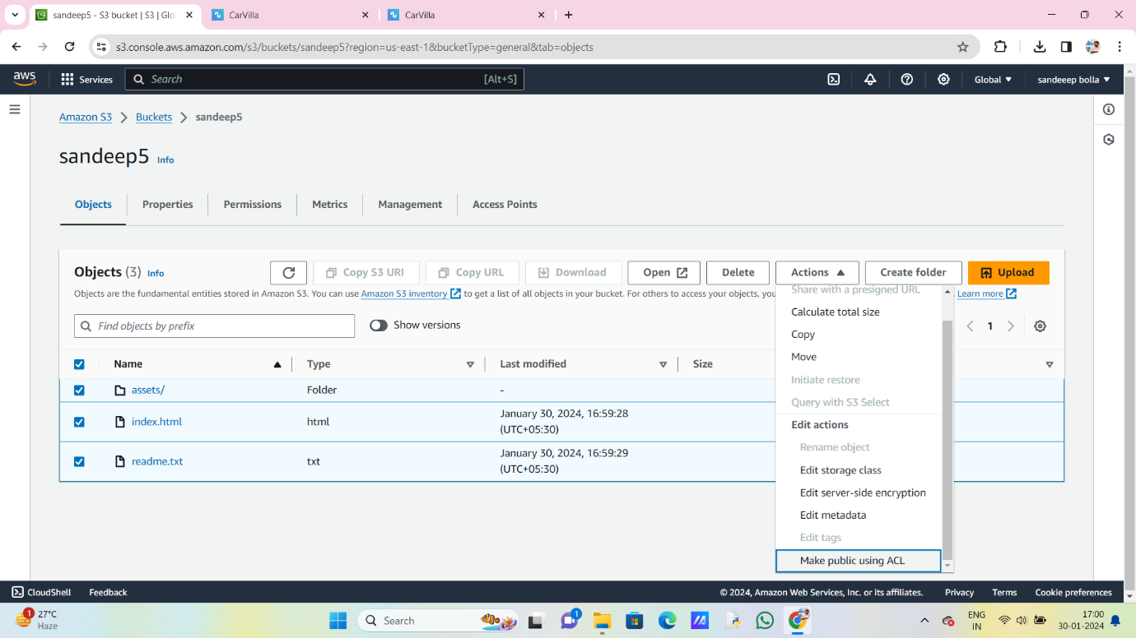

ii) Make it as public ACL



**STEP 5:**

**Configure Bucket for Website Hosting:** In the bucket properties, enable static website hosting and specify the index and error documents.

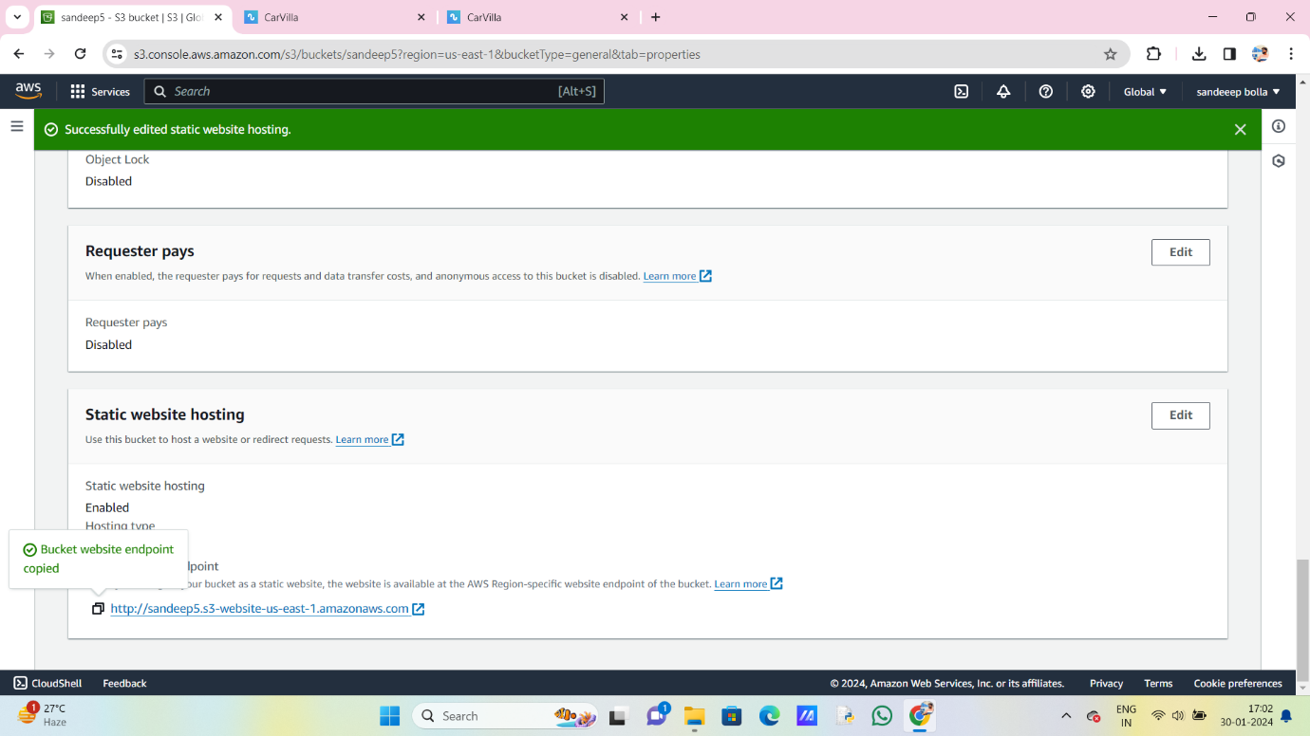

**STEP 6:**

**Set Permissions:** Update the bucket permissions to allow public read access to the objects. You can do this by applying a bucket policy or configuring access control lists (ACLs).

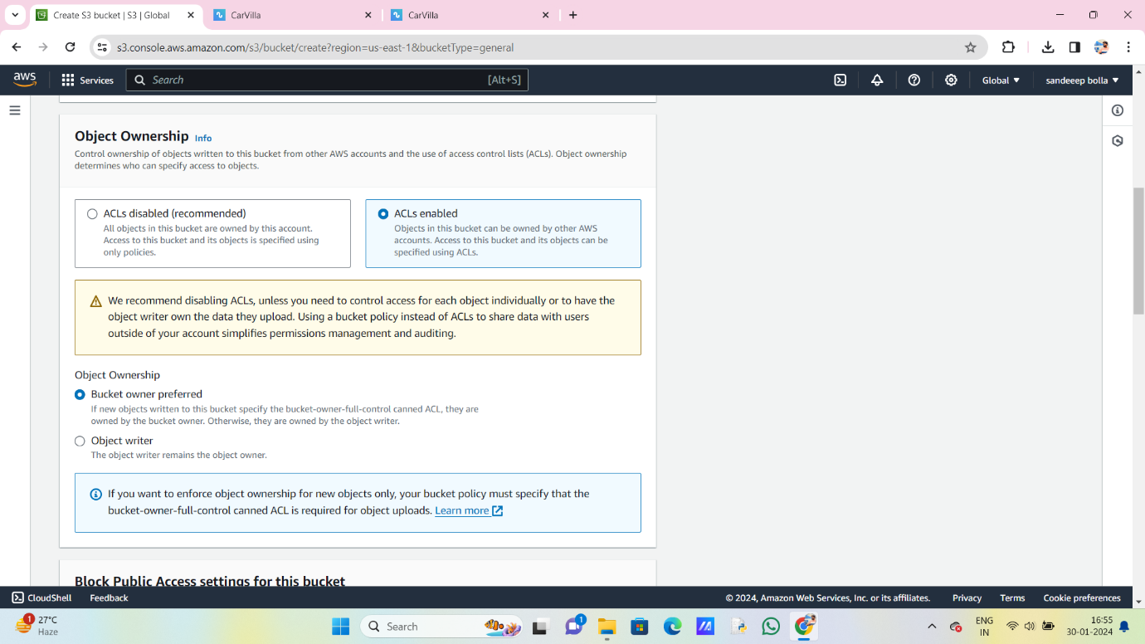

**STEP 7:**

**Configure DNS (Optional):** If you have a custom domain, configure DNS settings to point to the S3 bucket endpoint. This involves updating the DNS records with your domain registrar or DNS provider.

**STEP 8:**

**Test Your Website:** Access your website using the provided S3 bucket endpoint or your custom domain. Verify that all pages load correctly and that assets are being served as expected.



**NOTE:**

**Optimize and Monitor**: Monitor website performance and user experience. Consider implementing features like caching, compression, and CDN (Content Delivery Network) integration for improved scalability and speed.